Chapter 12, Solution 82.

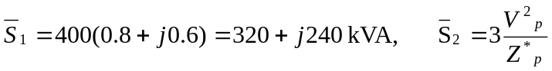
For the delta-connected load, 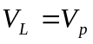

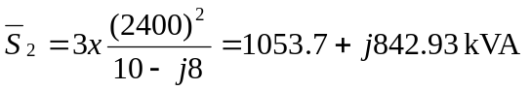
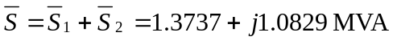
Let I = I₁ + I₂ be the total line current. For I₁,

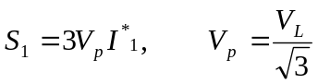
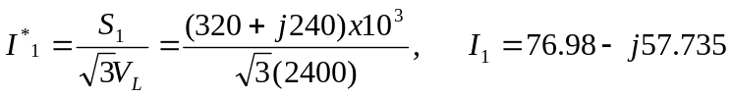
For I₂, convert the load to wye.

